**COMP SCI 4HC3**

**DESIGN Project Milestone # 2**

**UI Design**

Marek Ceglowski - 1150038

David Elsonbaty - 1141043

Mathew Wood - 1138343

Rhett Amin – 1060085

**Part 1 – Personas**

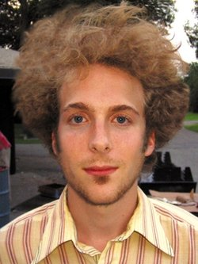

Name: Garth Wayne

Location: NYC, New York

Age: 27

Profession: Comic artist

*“Design is my passion!”*

**Details(story)**

Garth Wayne is a 27 year old artist from New York. He his a full-time self-employed comic artist and a part-time 3D modeler. He likes to draw and create comics, blog about his life and experiences, taking pictures of various subjects, and does 3D modeling in his spare time. Because of his job and hobbies, Garth owns a Macbook and carries it with him everywhere he goes. He is highly proficient with it, and knows his way around the software. He has also developed his personal site using Wordpress.He also does his 3D modeling and comics using a sketch pad and stylus. Through his use of his macbook over the years, it has become slow and it crashes often, which annoys Garth. He needs to buy a new one, but doesn’t have the money to afford a new one.

Garth has attended the Academy of Art in New York, where he developed his artistic style over the 4 years he attended. He has taken what he has learned and uses it for is comic and his modeling, which he wants to use to earn a position either at Disney or Pixar.

Garth also really loves designing every aspect of his life, and he constantly changes them. From his apartment, to his clothes, to the layout of the apps on his phone, he changes the designs to keep his creative juices flowing.

**Details (point form)**

|  |  |
| --- | --- |
| Computer experience   * high, knows the ins-and-outs of his macbook, * Uses a design tablet to draw his comics * He has created a website using Wordpress * Does modeling in 3DS Max. * Needs a new laptop, as his is slow and crashes | He has his own website where he displays his comic. The website also includes his blog, and a gallery of pictures he has taken and small sketches he does. He also is a part-time 3D modeler. |
| Education   * Attending New York academy of Art for 4 years. * Here he developed his current artistic style he uses for his comics. * He has been drawing since he was a 16, and his talents accelerated when  he finished the program. | He likes to design everything in his life, from his apartment, to his clothing style, to the layout of the apps on his phone. He constantly changes everything about his life, to help keep his creative juices flowing. |
| Goals   * Becoming a 3D modeler for Disney or               Pixar.   * Having every aspect of his life perfectly designed | Likes - Art, food, coffee, watching plays, taking pictures, drawing, modeling  Dislikes - When his computer crashes, rude people, cats |

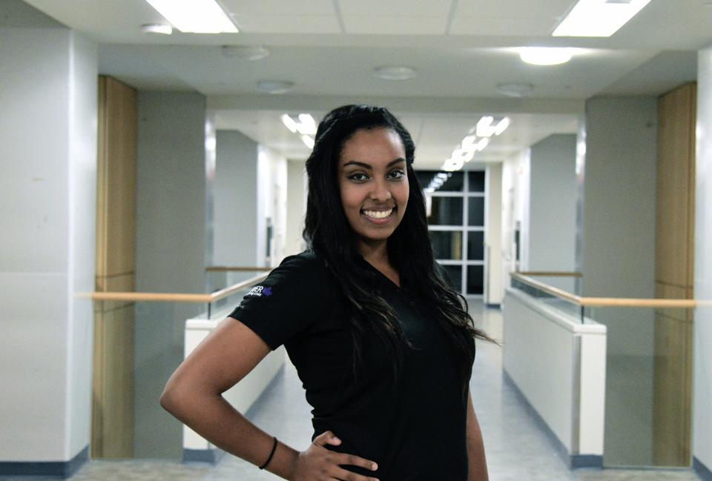

Name: Catey Smith

Location: TO, Ontario Canada

Age: 21

Profession:  Health Science Student

*“A great life starts with Great health”*

**Details(story)**

Catey is studying health science at University of Toronto. She’s hoping to become a dentist in the near future. She’s a good hearted person who goes out of her way to help others in need.

She is constantly thinking about random things, if she’s not asleep then there’s something going through her head. She wants to write a book about all her thoughts and everything that goes through her head one day.

Catey is an average girl who enjoys listening to music, helping people, and capturing life’s best moments. She admires good photos, and tries to perfect her images using computer softwares which offer smart photo editing filters.

**Details (point form)**

|  |  |
| --- | --- |
| Computer experience   * low, minimum technical knowledge * Uses computer for browsing, word processing and facebook * Uses consumer software to edit photos * Has no hardware related knowledge | She is just an average student, uses computer for school, taking pictures with her Canon Camera, research and social browsing . She also enjoys browsing pinterest and instagram, and going to clubs every weekend. |
| Education   * Third year health science student * Attends University of Toronto, and is in her 2nd year. * Member of the clean living club | Likes - Art, food, music, taking pictures, helping others, editing photos using smart filters, pets and socializing |
| Goals   * Aspires to become a dentist one day * Likes to write short stories in her spare time | Dislikes - disrespectful people, things not working as expected |



Name: Kaeden Bradley

Location: Phoenix, Arizona, US

Age: 10

Profession:  N/A

**Details(story)**

Kaeden is a kid whose life has yet to begun. With no real responsibilities he spends most of his time playing video games. Kaeden will get upset if he doesn’t get the things that he wants. This includes not having McDonalds for every meal of every day. His experience with computers so far is very limited as he usually sticks to console gaming because using a mouse to aim is too hard. His older brother has tried letting Kaeden play games on his computer which led to Kaeden yelling almost every five minutes about the character’s view being too jumpy and then proceeding to throw the mouse across the room and run out crying.

**Details (point form)**

|  |  |
| --- | --- |
| Computer experience  -       Knows how to turn on computer  -       Can install new software by continuously clicking “yes” or “next”  -       Uses computer for raging, trolling, and harassing other fair patrons of the internet  -       Has no hardware related knowledge | The average child on the internet. Uses the computer only to play games or find trouble on the internet. |
| Education  -       Grade 5  -       Plays indoor soccer | Likes – Playing video games, watching cartoons, chewing bubble gum, and collecting Yu-Gi-Oh cards. |
| Goals  -       Really wants to grow a moustache  -       Wants to prestige at least 3 times in CoD | Dislikes – Homework, campers, losing. |

**Part 2 – Design**

*Main Screen – Iteration # 1*

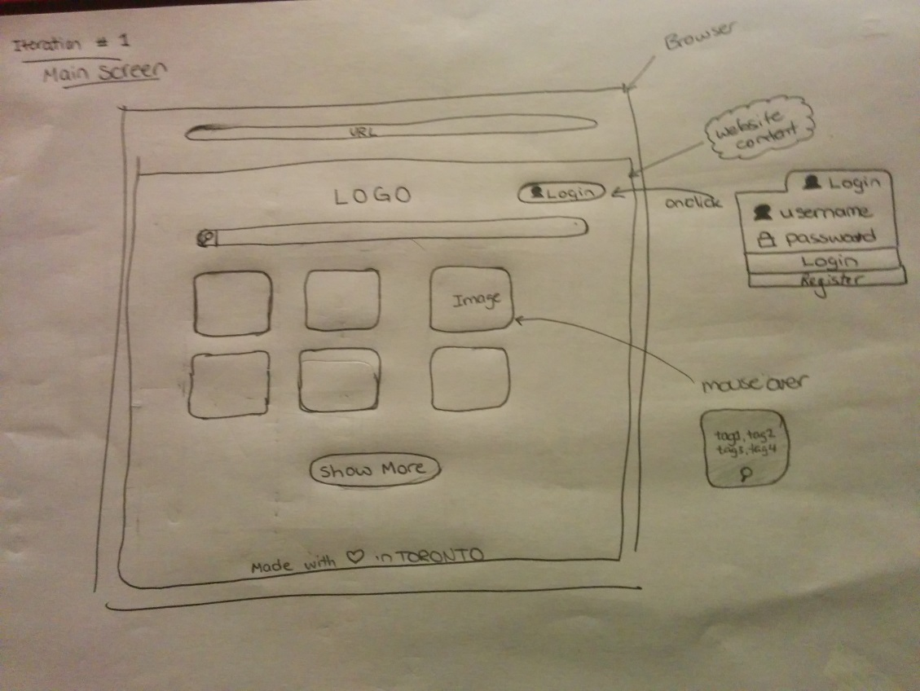

*Main Screen – Iteration # 2*

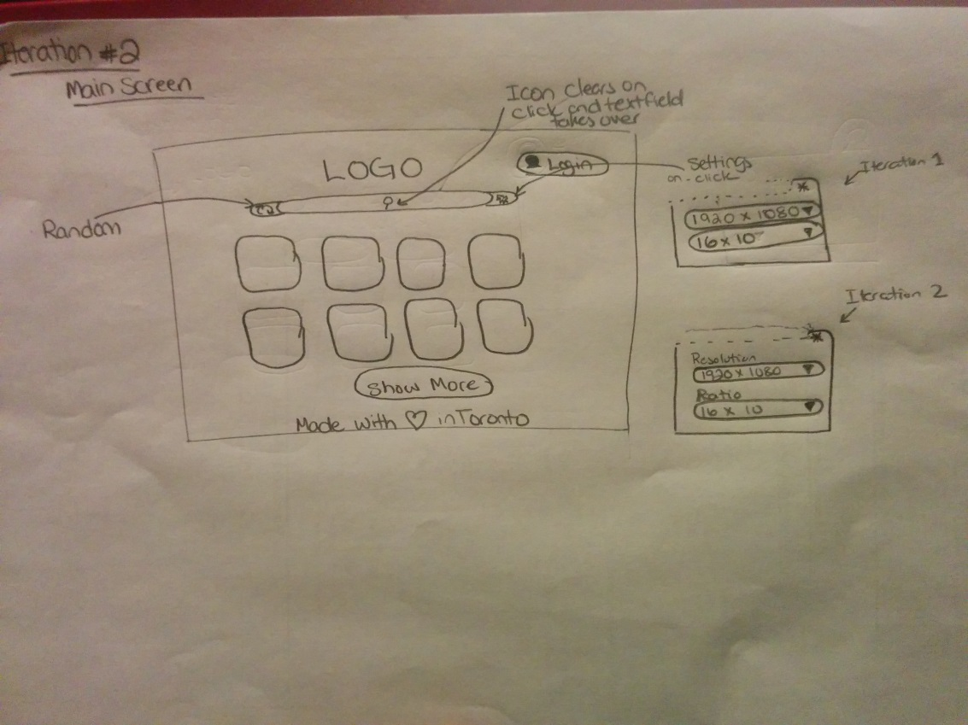

*Main Screen –Iteration # 3*

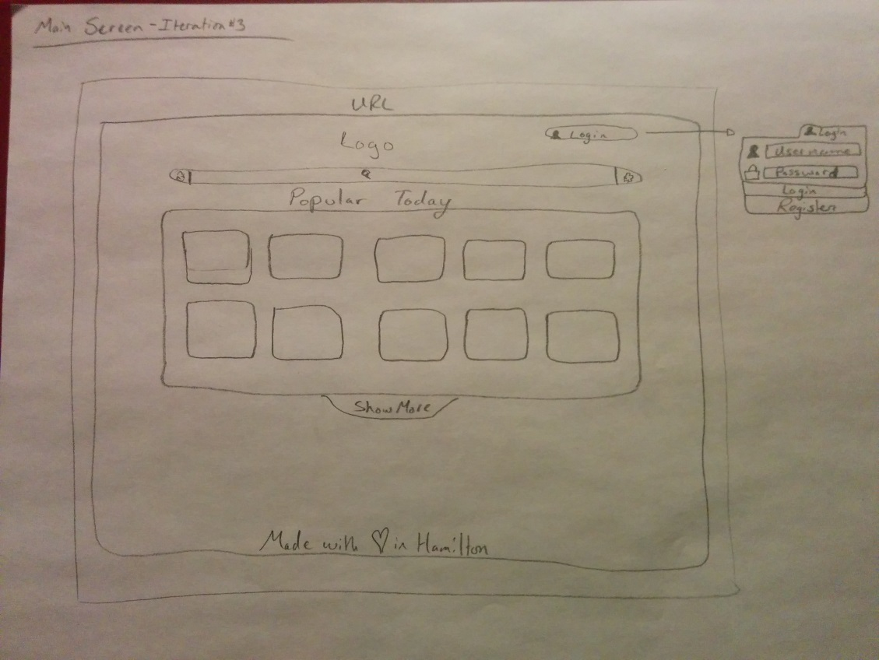

*Main Screen – Iteration # 3-a (Options panel expanded)*

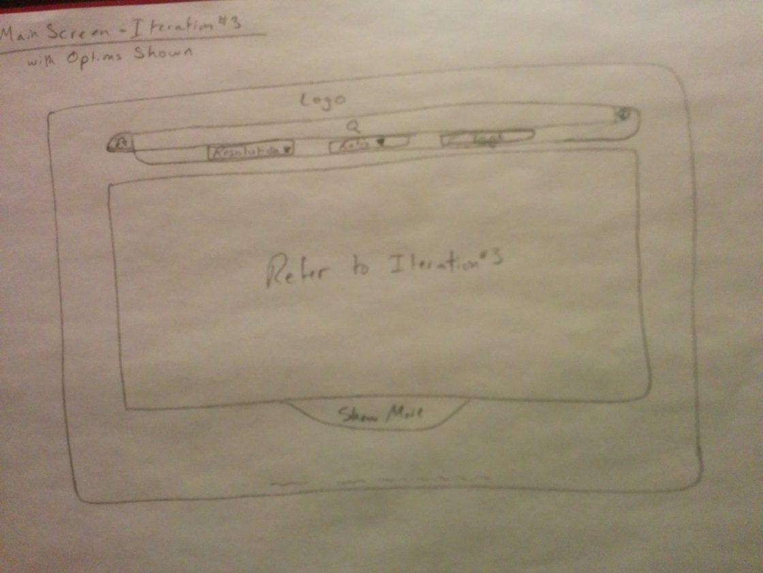

*Profile Screen – Iteration # 1*

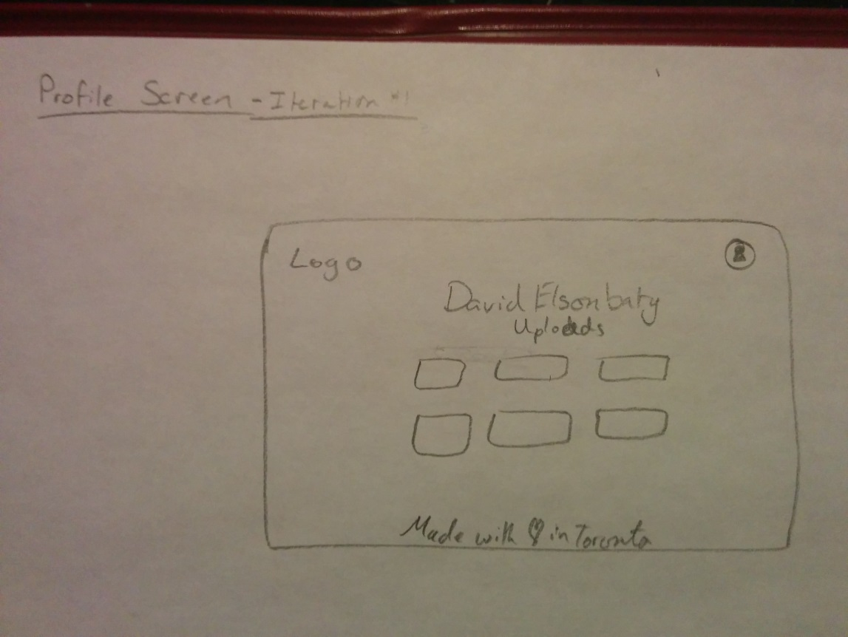

*Profile Screen – Iteration # 2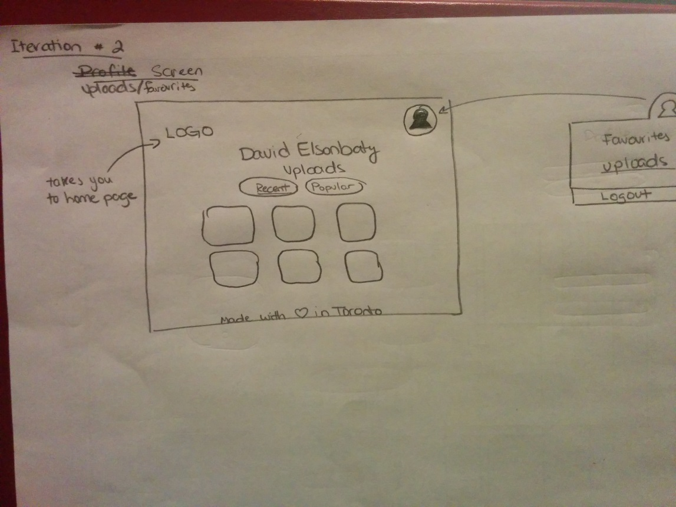*

**Part 3 – Visual HTA’s**

*Downloading a wallpaper on through our design*

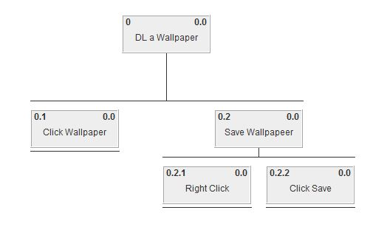

*Uploading a wallpaper through our design*

